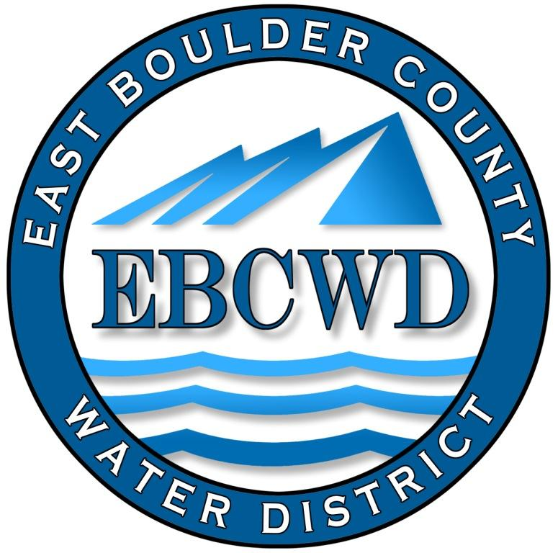
East Boulder County Water District
P.O. Box 18641, Boulder, Colorado 80308-1641
303.554.0031 ◆ www.eastboulderwater.com

Board of Directors Regular Meeting

Meeting Held at St. Ambrose Church

10 April 2023

Mark Johns (President) was unable to call the meeting to order because of a lack of a quorum of the board. Those present were Mark Johns and Bob Champ. Mary Wagner (Bookkeeper) was also present. No members of the public were present. Terry Kenyon (Engineering) was present to discuss the Benchmark Pipeline.
Mary noted that Lafayette had increased their water rates by 5%.
Terry had a map of the Benchmark Area with his proposed new pipeline. Terry discussed his proposal noting that the next step would be the public noticing asking for bids. Terry will also contact the Benchmark HOA to make sure that they are aware of the plans for the pipeline.
Mark noted that he will be out of town from 5/4 to 5/21 and will miss next month’s meeting.
The secretary respectfully submits the above.
Robert Champ; 4/10/23

