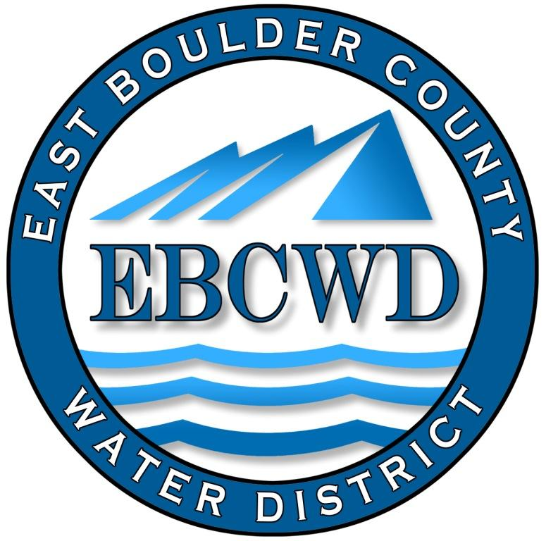
East Boulder County Water District
P.O. Box 18641, Boulder, Colorado 80308-1641
303.554.0031 ◆ www.eastboulderwater.com

Board of Directors Regular Meeting

Meeting Held at St. Ambrose Church

13 November 2023

Mark Johns (President) called the meeting to order at 4:17 PM. Those in attendance were the board members Bob Champ, Yvonne Gates and Catherine Gee. Marsh Lavenue was present via phone. Mary Wagner (Bookkeeper) was also present.

Public Comments
No members of the public joined the meeting.

Secretary’s Report
The minutes of the 9 October 2023 meeting were discussed. Mark clarified that the State Grant, if allowed, would be for the cost of flushing hydrants. Marsh will make the change.
Mark Johns made the motion that we approve the minutes of the 9 October 2023 meeting. Yvonne Gates seconded the motion, which was unanimously approved.

Reports from Consultants and Committees

Finance Report
Mary Wagner had e-mailed the financial packet to the board. The water usage spreadsheet was also e-mailed.
Mary noted that she had transferred $20k from Colotrust to checking.
Mary went through the rest of the financial statements and the board approved the financial statements and the transactions.

IT Report
Marsh had e-mailed the monthly report from Omni to the board. The monthly costs were $105.

System Operations Report– 10/1/2023 to 10/31/2023
10/04/2023 | - (JR) Pump house check 0.72mg/l free
10/11/2023 | - (JR) turn off water t 7456 Empire Dr.  - (JR) pump house check 0.73 mg/l free
10/18/2023 | - (JR) pump house check 0.58 mg per liter free  - (JR) collect water sample 1027 Paragon Dr. 0.31 mg/l free and deliver to the lab
10/25/2023 | - (JR) Pump House check 0.49 mg per liter free  - (JR) tank inspection and report  - (JR) Final meter reading 7579 Panorama Drive
11/02/2023 | - (JR) Meter reads

System Operations Report FIRE WORK– 10/1/2023-10/31/2023
10/03/2023 | - (JR) Locate 4 Benchmark, 7509, 7487 Panorama, 7352 Empire
10/04/2023 | - (JR) Locate 12 Benchmark Drive, 1027,1029 Paragon Drive, 7249 Spring Drive, inspect water line at foundation entry at 7553 Skyway ct.  - (JR/Sam) flush hydrants
10/10/2023 | - (JR) Locate 173 S. 80th, 281 Ponderosa Dr.
10/11/2023 | - (JR) Locate 7289 Spring Drive, 7305, 7214 Spring Court, Inspect water line connection at 7249 Spring Drive.
10/12/2023 | - (JR) Locate 753 Paragon Drive, clear
10/13/2023 | - (BRR) Locate 275 Paragon, 7348 Spring Dr, 0 Spring Drive and Spring ct.
10/16/2023 | - (JR) Locate 7249 Spring Drive, 777 Skyway Drive, 1027 Paragon Drive
10/18/2023 | - (JR) Locate longs peak Drive, clear, and 1000 Spring Drive  - (JR) Install meter and MXU at 7373 Spring Drive meter number 94049221 MXU number 130662456  - (JR/Sam) hydrant flushing
10/19/2023 | - (Jay) Locate 7439, 7487,7509 Panorama Dr, 7432,7340 Empire Drive
10/23/2023 | - (JR) Locate 1025 Paragon Drive, zero Spring Drive intersection, 1027 Paragon Drive
10/25/2023 | - (JR) Locate 7331 Spring Drive
Monthly | (Dustin) time spent in office coordinating locate tickets and managing CDPHE paperwork, updating spreadsheets Contractor requests for testing and inspections, etc.

Peter was absent from the meeting. It was noted that a large amount of work due to the fire was related to locates. We are going to talk to Peter regarding any measures that might reduce the cost of locates.
.
Unfinished Business

Marshall Fire
Yvonne noted that we are awaiting the possibility of getting a State Grant for about $25k for the hydrant flushing, which directly relates to water quality.

District Insurance

Currently we are awaiting quotes so that we might make a decision on our insurance provider. We obtained the value of the pump house and related equipment to be on the order of $700k. Mary noted that our insurance with our current carrier renews automatically on the first of next year.

Northern Water

Mark has talked to Lafayette regarding this matter. Lafayette said that they are still trying to figure out their approach to this matter. Mark noted that new tap fees might be significantly more expensive as the potential customer may have to purchase a water share from the Northern Water Conservancy District at the cost of approximately $70k. This would put the cost of a new water tap well over $100k. We will have to wait to see what, ultimately, the financial implications will be to our District members.

Water Services Line Survey

Marsh and Mark plan to attend a webinar regarding this subject.

New Business
Budget Hearing for 2024 Budget
Mark Johns made the motion that we open the budget hearing. Yvonne Gates seconded the motion, which passed unanimously.
The budget hearing was noticed in the Daily Camera. Mary went through the appropriate budget documents.
Mark Johns made the motion that we adopt Resolution 2023-B1 which adopts the Water Enterprise Fund Budget and appropriates sums of money for the year 2024. Yvonne Gates seconded the motion, which passed unanimously.
Mark Johns made the motion that we adopt the budget message for the Water Enterprise Fund for 2024. Yvonne Gates seconded the motion, which passed unanimously.
The necessary documents will be signed and Mary will forward the appropriate documents to the Division of Local Governments. The budget documents are attached to the minutes.
Mark Johns made the motion that we close the budget hearing. Yvonne Gates seconded the motion, which passed unanimously.

Possible Charge to Owners for Services Line Inspection

After discussing the cost of this service to the district, it was determined that we should reclaim the cost of this service by charging a fee of $155 to owners. This fee would not be retroactive, but would be effective immediately. Yvonne Gates made the motion that we charge customers a fee of $155 for a service line inspection, effective immediately. Catherine Gee seconded the motion, which passed unanimously.

Directors Comments and Other Matters to Come Before the Board
Bonuses for our contractors were discussed. It was decided that due to our financial stress due to the fire that we should pay bonuses at the same level as last year. Mark Johns made the motion that we should pay our contractors the same bonus as last year. Yvonne Gates seconded the motion, which passed unanimously.

Catherine has kindly offered to have the board plus contractors for dinner after the next meeting.

Adjourn
A motion was made to adjourn by Mark Johns, seconded by Yvonne Gates and unanimously approved. The meeting was adjourned at 5:30 PM.
The secretary respectfully submits the above.
Robert Champ; 11/13/23
