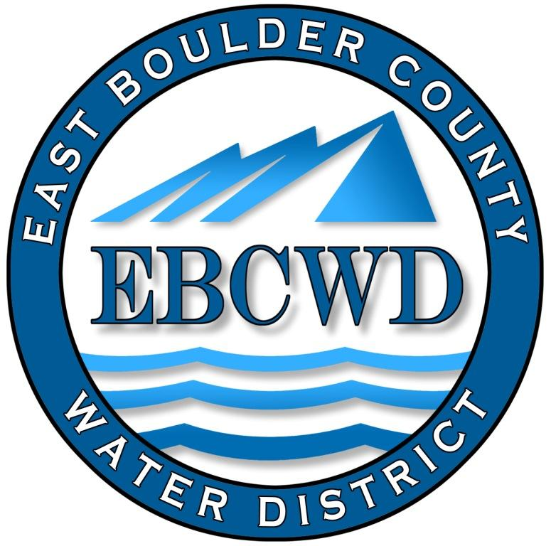
East Boulder County Water District
P.O. Box 18641, Boulder, Colorado 80308-1641
303.554.0031 www.eastboulderwater.com

Board of Directors Regular Meeting

Virtual Meeting Held with Zoom

14 February 2022

Mark Johns (President) called the meeting to order at 4:00 PM. Those in attendance via video were the board members Marsh Lavenue, Catherine Gee, Yvonne Gates and Bob Champ. Mary Wagner (Bookkeeper) and Peter O’Brien (Operations) were also present. Lars Kalnajs from the public also joined the meeting via the zoom call.

Public Comments
Lars brought up the point that he was representing many people in the district who had lost homes yet still would like access to water so that they could maintain their trees and landscaping. This would also benefit both the homeowner and the district (the district would get water revenue). To do this a yard hydrant would be necessary and installing this would have to be coordinated with the state. This topic was discussed later in the meeting with respect to the Marshall Fire.

Secretary’s Report
The minutes of the 10 January 2022 meeting were discussed.
Mark Johns made the motion that we approve the minutes of the 10 January 2022 meeting. Yvonne Gates seconded the motion, which was approved unanimously.

Reports from Consultants and Committees

Finance Report
Mary Wagner had e-mailed the financial packet to the board. The water usage spreadsheet was also e-mailed.
Mary noted that she had transferred $20k from Colotrust to checking to cover expenses.
The audit exemption has been finalized ($445).
A credit was made to homeowners for excess water used because of the fire. This adjustment was made to the December income. Mary has the amount of water used/lost during the fire for insurance purposes.
Expense for the Marshall Fire so far has totaled $23,773.87.
Mary went through the financial statements and the board approved the financial statements and the transactions.

IT Report
Steven again checked the system and all was okay. Labor for the month was 1.5 hours.
System Operations Report – 01/12/2022-02/09/2022
01/12/2022 | - Pump house check 0.92mg/L Free  - Locate 7550 Spring Dr.
01/19/2022 | • (Jay) pump house check 1.01mg/L Free
01/26/2022 | - Diagnose failed UPS at pump house  - Locate 777 Panorama Ct.  - Locate 7444 Empire Dr.  - 562 Ponderosa Dr. found pressure regulator in meter pit slowly creeping up to 80 psi, needs replaced  - Pump house check 1.23mg/L Free
02/01/2022 | - Meter reads  - Replace ups power backup  - Locate 7780 and 7676 Spring Dr.  - Locate 7420 Panorama Dr.  - Pump house check 1.09mg/L Free
02/03/2022 | - (Jay) Locate 963 Paragon Dr.  - (Jay) Locate 7352 and 7425 Empire Dr.
02/07/2022 | - Locate 7526 Spring Dr.  - Pump house check 0.67mg/L Free  - meet with generator company Energy Mgt.  - Water Analysis, Potability CA 0.96mg/l
02/08/2022 | • collect sample and deliver to the lab
02/09/2022 | • Pump house check 0.56mg/L Free

Peter addressed the problem with the generator. He noted that the problem occurs only when all 3 pumps are running. He is meeting with the generator company on Wednesday to try and resolve the problem. Peter then discussed the following fire report.
System Operations Fire Report – 12/31/2022-01/31/2022
12/31/2022 | • 3 men assessment of damages and begin shutting off customer taps
01/01/2022 | • 3 men continue with shut offs
01/02/2022 | • 3 men continue with shut offs and begin flushing water lines
01/03/2022 | • 1 man continue with flushing water lines, and collect samples and deliver to the lab
01/08/2022 | • wash down of generator, clean radiator, clean compartment and battery box, clean shrouds, wipe down gauges and switches, full-service oil change, air filter, and oil filter. Bleed air from gas lines, check operation of generator starting automatically, check transfer switch operation, check startup of emergency pump
01/12/2022 | • 1-man clean debris from prv valve
01/14/2022 | - Collect water sample bottles ioc, voc, pota,  - 7420 panorama after flushing the water lines and return samples to the lab for analyzing
01/17/2022 | • 2 men flush hydrants on and near Panorama Dr.
01/18/2022 | • 3 men flush individual taps on empty lots, and flush hydrants
01/28/2022 | • meetings, phone calls and emails with CDPHE and EBCWD regarding cross connection, sampling, do not drink notice, and burn area/system maps
01/24/2022 | • meeting for EBCWD with Andy from Purdue. we discussed sampling, mapping, meters, service lines, flushing and meter pit sampling devices.
01/31/2022 | • 2 men collect voc samples and flush water lines

Peter did note that some of the meters in the burned homes did have remote reader damage and will have to be replaced. Pete and Mark will discuss this matter on Wednesday.

Unfinished Business
2022 Election
Mark and Catherine have the self-nomination forms for the upcoming election. The last day for submission of self-nomination forms is next Friday. If no other self-nomination forms are received Mary will cancel the election.
Audit Exemption
Mary has submitted the audit exemption.
Yvonne Gates made the motion that we approve the resolution for the audit exemption for the year 2021. Bob Champ seconded the motion, which was approved unanimously.
Marshall Fire
Meeting with Professor Andrew Whetton of Purdue University
Mark and Peter talked with Professor Whetton regarding our response to the fire. Basically it was determined that we would follow the state guidelines.
Hydrant Meters/Rates for Water
Yard hydrants for irrigation purposes were discussed. A backflow device would have to be installed in order to use such a device. The state would have to be involved with respect to providing water to burned out homes. Peter had information on yard hydrants that might be used. This subject will have to be discussed further.
Water will have to be used in treating the contaminated burned out site. In lieu of having water trucked in, it was discussed whether we could provide water via our hydrants. Peter noted that meters for fire hydrants are available and thereby we could provide water for this purpose. We would have to be competitive with the outside source. Marsh will look into what we might charge for the water provided.
COWARN
This item was tabled until the next meeting. Marsh will look into how we might join, if necessary.
FEMA
We have 60 days to file damages to FEMA. All damages after insurance coverage should be tracked and can be filed with FEMA. Labor hours will have to be documented. Pete will obtain the necessary forms. FEMA may pay only 75% of damages.
District’s Insurance
Mark noted that loss of income is not covered under our insurance. Peter’s time will be covered. Mark had e-mailed a letter from our insurance representative to the Board summarizing the information we need to provide them with regard to the fire.
Evaluation of Fire Hydrants
Peter has examined the hydrants and no operation difficulties were noted. Meters for the hydrants are available and Peter will look into where to obtain them and the cost.

CDPHE
Mark had e-mailed a letter from the Colorado Department of Public Health and Environment to the Board regarding Controlling and Correcting cross-connections caused by the fire. This matter was discussed in some detail as to how we might have to begin providing water to burned out homes/land. We have one homeowner who needs water for a barn with livestock so this matter will be addressed in the near future. We ultimately will have to follow CDPHE protocol when water is provided to the affected homes. Peter is aware of this matter and will work with CDPHE when necessary.

New Business
Designate Meeting Place
Mark John’s made the motion that we continue meeting via zoom on the second Monday of the month at 4 pm and that the meeting agenda will be noticed on the web site and on the pump house. Bob Champ seconded the motion, which passed unanimously.
Wells at Lot 9 Panorama and Benchmark
It has been determined that the Benchmark Well ownership was never transferred over to the district.
The well on Lot 9 does belong to the District as it was transferred to us when Panorama Park Water Association became part of the District. There was some concern by the homeowner of lot 9 that when he builds on this lot there may be some leach field location concerns. However after discussing it was determined that it is in the best interest of the district to keep this asset.

Directors Comments and Other Matters to Come Before the Board
Catherine brought up the concern with respect to possible damage to the water storage tank. Mark will talk to our engineer regarding his assessment and Peter will look into inspecting the tank.

Adjourn
A motion was made to adjourn by Mark Johns, seconded by Yvonne Gates and unanimously approved. The meeting was adjourned at 6:13 PM.
The secretary respectfully submits the above.
Robert Champ; 2/14/22

